Parents’ Perspectives About the Effects of COVID-19 Upon the Social
and Emotional Well-Being of Their Young Children
Joanne Robertson-Eletto
Touro Graduate School of Education
New York, New York, USA
Master of Science in Teaching Literacy (B-12)
joanne.robertson12@touro.edu

Parents’ Perspectives About the Effects of COVID-19 Upon the Social and
Emotional Well-Being of Their Young Children
Abstract
The collective voices and experiences of parents living in the greater New York area during the peak, decline, and resurgence of COVID-19 infections (2020-2021), and their perceptions about the short and long-term effects of the pandemic upon their young children’s (3- to 8-year-olds) social and emotional well-being are presented in this chapter. Due to “social distancing” mandates, fifteen parents were contacted via social media, and invited to share their thoughts and experiences about the effects of Coronavirus upon their children’s evolving thinking and attitudes. Data sources included parent emails/text messages/phone conversations, real time notes scribed in a researcher’s journal after conversations, family forum postings, photographs, personal experiences with my granddaughters, as well as newspaper articles, and educational/research publications that extended the research data beyond the immediate parent population. Data was collected and evaluated from March of 2020 to March of 2021. Grounded theory methods were used to qualitatively gather and analyze parents’ and children’s comments, code and develop emergent themes that explore the ways families made sense of the historical and unprecedented contexts of a long-term quarantine, lock-down, social distancing, and virtual learning environments. Grounded theory permitted the simultaneous collection and analysis of the data, using a systematic and inductive approach to develop the dominant domains of analysis for the spring, summer, and fall of 2020. Implications and suggestions are provided for families, early childhood teachers, and early childhood teacher educators. (233 words)
Key Words: COVID-19, early childhood, cognitive and emotional development, parents’ perspectives, qualitative research, literacy and learning

Introduction
Young children are “meaning makers” (Wells, 2009), who make sense of the world through conversation and interaction with the significant people in their lives. The seminal research of Lev Vygotsky (1970) highlights the ways young children use speech to think “out loud,” before internalizing new concepts. Therefore, much can be learned by paying attention to what young children say and do, especially during the stressful contexts of a national pandemic, mandated quarantines, social distancing from family and friends, school closures/re-openings, and learning virtually via ZOOM.
The purpose of this 12-month analysis of parents’ and children’s perspectives, is to describe, preserve and document the effects of COVID 19 upon young children’s sensibilities and feelings about self, family, and the world. Similar to a social archivist, I collected bits and pieces of information from multiple sources (research studies, parent social media groups, emails, newspaper articles, and my two four-year-old grandchildren) to better understand the ways young children made sense of the virus over the course of one year.
Genishi and Almy (1979) write, “Children’s movements, their gestures, their changing facial expressions, -their comments – all their responses offer some clues about what they’re learning, what they have learned, what they feel, and what they think” (p. 21). In this chapter, first-hand and real time accounts about the effects of changing family routines, social isolation from friends and extended family members, and transformed learning contexts impacted the well-being and learning of young children living in the greater New York area from 2020 to 2021. The focus of this chapter is the young child (ages 3-8), as so many perceptions of self and “theories of the world” (Smith, 1985) are developing during these critical years. Much can be learned by recording and reflecting upon young children’s words, thoughts, and actions. Parents and children’s comments are interspersed throughout the chapter.
Research Methodology
Grounded theory methods (Glazer & Strauss, 1967) were used to gather and analyze parents’ and children’s comments, code, and develop emergent themes/domains of analysis, and explore the ways families and young children made sense of the unprecedented contexts of COVID-19 lock-downs, social distancing, and virtual learning environments. In addition, newspaper articles, photographs, and educational publications are integrated for additional perspectives. This flexible, qualitative method permitted the simultaneous collection and analysis of multiple sources of data, and the use of a systematic and inductive approach to develop and extend domains of analysis. Findings and conclusions are compared and contrasted with global studies about the impact of COVID-19 upon children’s education, health, and overall well-being.
Data sources included parent emails/text messages/phone conversations, real time notes scribed in a researcher’s journal after conversations, family forum postings, photographs, personal experiences with my granddaughters, as well as newspaper articles, and educational/research publications that extended the research data beyond the immediate parent population. Data was collected and evaluated from March of 2020 to March of 2021. Grounded theory methods (Glazer & Strauss, 1967) were used to qualitatively gather and analyze parents’ and children’s comments, code and develop emergent themes that explore the ways families made sense of the historical and unprecedented contexts of a long-term quarantine, lock-down, social distancing, and virtual learning environments. My task was to discover the stories embedded in the data.
Participants
Due to “social distancing” and quarantine mandates, parents were contacted through social media, and invited to share their thoughts and experiences about the short and long-term effects of Coronavirus upon their children’s thinking and attitudes. Two of my daughters-in-law are members of parent forums, and they initiated the first outreach to members. Fifteen parents of 3- to 8-year-olds (all women), from their online parent forums, responded to the invitation through texts, emails, and personal communications, expressing a desire to be part of this study. Some had more than one child in the age group, and wrote about each of them. All participants were guaranteed anonymity, and email permissions were obtained to use comments, photographs, or children’s work samples. In addition, I joined an urban and suburban family forum, and analyzed the patterns of the postings over the course of a year. Data collection began in April, 2020, and its analysis until March, 2021.
Research Question
An open-ended, guiding question was used to collect the first responses. This nonleading question was: What are the effects of the COVID-19 pandemic upon your child? Parents’ requests for more clarification lead to the refinement of this question to include children’s thinking, attitudes, overall well- being, and ultimate transition back to school.
Participants were encouraged to include their children’s words or reactions, to illustrate their evolving thinking about the nature and implications of Coronavirus for their own lives. Parental reflections, informed by children’s comments/behaviors about learning at school, virtually/hybrid, or at home in the spring of 2020 to the fall of 2020 are integrated throughout.
Researcher Positionality/Bias
Denzin (1998) states, “The Other who is presented in a text is always of version of the researcher’s self.” Krieger (1991) adds, “images of ‘them,’ are images of ‘us.’” Indeed, this is the case in my analysis and evaluation of the data. I make no claims regarding researcher objectivity, as I am a New Yorker and member of the community. I most definitely have an emic perspective. Therefore, my interpretations are uniquely mine, and not generalizable to other people or contexts.
This chapter is all about “capturing the lived experiences” (Jalongo & Saracho, 2016) of a particular group of New York parents, and one grandmother with two young grandchildren, living through a national and global pandemic of unprecedented proportions. The goal is to provide insights into their day-to-day lives and thinking. I have interspersed the thoughts of parents/caregivers and children to give them prominence throughout the narrative.
As I began writing this chapter in February, the daily COVID death tolls surpass the 3,000 lives lost on 9/11, or even on D-Day. I had friends and family members struggling to survive because of the devastating effects of Coronavirus upon their lungs. At the time I was revising the chapter in March, three new vaccines became available to essential workers and various age group. Therefore, I was an eye-witness to the historical contexts of which I wrote, and blended my voice with those of the participants to tell this story.
Maintaining a Sense of Normalcy
Spring, 2020
During the “Coronavirus Spring” of 2020, parents/caregivers were understandably worried and anxious about school closings and quarantines, but thankful for the extra time with their children. They attempted to create active, playful learning experiences that would interest their children, and meet their social, emotional, and developmental needs. “Retro” activities such as board games, bike riding, flying kites, and even fishing made a come-back. During free times when their children napped, or finally went to bed, parents/caregivers completed their home and job-related responsibilities. They believed the situation was temporary, and strove to maintain a sense of normalcy. Christina, a parent stated, “We sheltered them from the severity of the virus and people dying, but we made it clear we couldn’t be around anyone…Our goal was to keep our house running as normal as possible.”
Many parents embraced these new responsibilities with eagerness, energy, and joy. They networked within their communities and parents’ groups for ideas, and scoured the web for enrichment activities. Children’s appreciation of differing family routines and structures was a dominant theme in parents’ comments. Brittany, the mother of two young boys commented:
My four-year-old said to me "Mama, I really like that we are all home" He has always been very attached to me and home, so he likes being here and also likes that my husband is home now too...way more than he ever was before! So, part of this has been very good for our family. On the other hand, my husband and I were both working at home with three kids, so some days were not so pretty!!

A month or two later, parents and caregivers would be asked to assist their children to complete learning assignments sent via computer from the teacher. The transition to home schooling was a transformative experience for teachers, parents, and young children. Many school districts did not have enough tablets/Chromebooks to distribute to students. Those who were lucky enough to receive one, often had to share it with other family members. Since libraries were closed, not all families had access to computers, and in some cases Wi-Fi. Many children were underserved in these beginning months, most especially children of color and those of low socioeconomic status. Inequities in educational resources were brought to light by the COVID-19 pandemic.
In May, my four-year-old granddaughter, Lilly, began verbalizing her thoughts about “germs,” and how they were living in the locked playgrounds. “When will the germs go away?” she asked. “They are everywhere, and I’m afraid of them.” She informed me that there would be “no sleepovers” at my house until they were all gone.
I also noted how reluctant she was to let her mother out of her sight. My daughter-in-law acknowledged her new “clinginess” and “melt downs” when she didn’t get her way. I was not surprised for the world as she knew it, had turned inside out and upside down within a matter of months, and it had begun to chip away at her sense of security and stability.
Simultaneously, my other four-year old granddaughter, was experiencing nightmares. Previously a sound sleeper, Nastassia, now imagined bugs under her pillow, lizards walking down the hallway, and even jelly fish swimming under her bed. Her words and actions allowed me to appreciate her thinking about COVID-19, and the ways it was disrupting her peaceful sleep routine. Her mother, Maria, videotaped and transcribed Nastassia’s bedtime prayer:
Oh Lord, thank you for keeping us healthy and safe, and make everyone be safe and go to bed safely. Please make no one get the Coronavirus, and please let everyone stay home and not go anywhere and get masks. Because they don’t want to get sick from the Coronavirus. Thank you, thank you.
Parents’ comments, email responses and forum postings helped me to understand children’s impressions about the virus. For example, Ilana wrote:
My 4-year-old has always been very verbal and perceptive and honestly, I am amazed most days how he has handled and adapted to COVID and quarantine. I don't think he fully understands the COVID virus itself. He knows it "makes people sick" and because of that we can't go to many places we used to go or see some people we used to see.
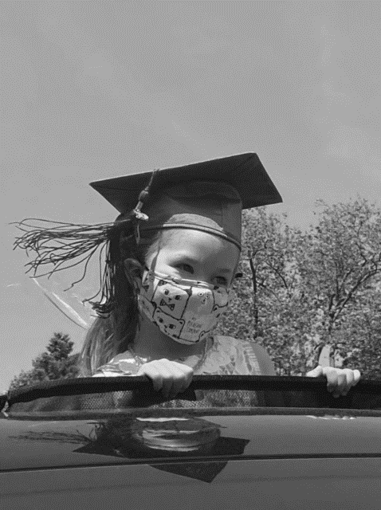
Figure 1. Lilly’s graduation ceremony from prekindergarten. She is peering from the sunroof of her father’s truck. Children received their diplomas while “socially distanced” in their cars.
Parents’ questions enabled me to appreciate the enormous challenges they were facing. Asking for what would be appropriate to write about for the chapter, Ellen provided me with the following list:
Not seeing friends? Not seeing family? Closure of parks, activities, PreK? Strengthening of family bonds? Adjustments to new parent work schedules? Adjustments to changes in plans? Coping with cancelled presents/vacations? Changes in routine? Memories of a Pre-Covid life? Adjustments to mask wearing? Mask tolerance? Fear or lack thereof? What it’s been like reopening, and to what extent have the adults attempted to keep things normal? New hobbies? How have they progressed or regressed over the six months? How have their expectations of daily life changed?
For the most part, schools began to shut down in March and remote or virtual learning became the norm. This further compounded the social and emotional affects of COVID upon young children’s sense of community. Alison, mother of a 3-, 4-, and 5-year-old wrote, “My four-year-old was most upset. She would get tears in her eyes telling me she missed her teachers and friends.”
Concurrently, families began to “social distance” from immediate and extended family members, adding to children’s feelings of isolation and loss. All the while, young children formed ideas and notions about what it all meant, as seen in Caitlin’s comment below:
At the height of the quarantine, we had a birthday parade for my niece Katie. We did get out of the car to say hello…When we got home, my son said to me, “So mama, Katie has Coronavirus?”
I said “No, why do you think that?”
He said “Then why can't I go near her?”
This just really showed me that while he understood the concrete "rules" we were telling him he didn't really understand the "why" of it all, and honestly that was hard for me to explain to his 4-year-old mind.

The New Normal
Summer, 2020
In the summer of 2020, as the weather became warmer, families began to meet in backyards, parks, and at beaches. However, they did so with trepidation. Children also expressed concern for the health of others.
My parents were in Florida during a lot of the pandemic. When they returned, we explained to my 4-year-old, that we couldn't see them for 2 weeks. As the two-week mark approached, we decided to visit them in the backyard and socially distance.
My son actually said to his grandmother a few times "Nonna, you can't get that close to me" or "Nonna, you can’t touch me.
As months progressed, many families took extended, but local, car trips to fill their days and keep the children occupied. However, they reported how nostalgia for the past resurfaced in their own thoughts and their children’s comments. For example, Debbie shared her five-year-old’s question. He asked, “When coronavirus is over can we.... [then he names it]....can we go to a hotel and stay over, can we go to the indoor play place?”
My own granddaughters turned five in August of 2020. I had not hugged them since the end of March, 2020.
This is Not Normal!
Fall, 2020
The fall was an anxious time for parents and young children. Parents worried about their children contracting coronavirus if they returned to classes, and children worried what it would be like to attend school again. Nevertheless, urban and suburban schools in New York opened on September 15, 2020 with a variety of schooling options (in- person, virtual, or hybrid) from which parents could choose. For the most part, parochial and private schools stayed open or hybrid. Public schools, including those in New York City, remained closed or minimally hybrid.
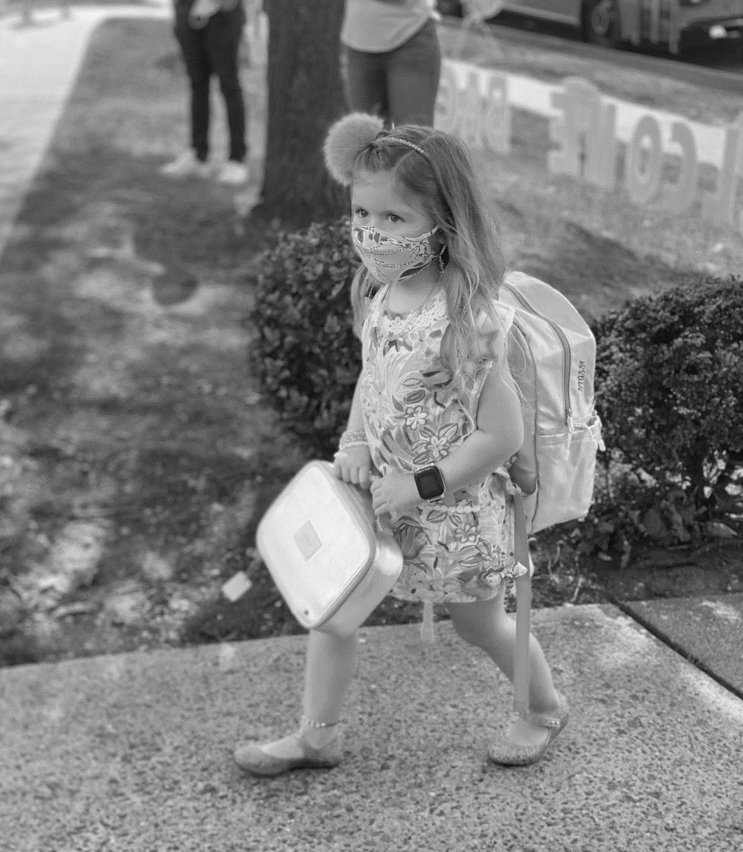
Figure 2. Nastassia walking to school on the first day of kindergarten, 2020.
Katie, a parent with a second grader, shared her thinking and her child’s about returning to school in the fall.
We gave my 2nd grader the option. He said he’d rather stay home. We said try a few in person days, and let’s see what you think. He agreed. He came home singing. He told us he’d rather wear a mask everyday all day than stay home. They played “air tag” at recess. He said it’s easier to learn in school than at home.
Others had different experiences. Ally spoke about the difficult decision she and her husband made in September:
I have a five-year-old. We lasted two days in the public kindergarten (expectation was five hours of ZOOM a day) and my husband is now homeschooling. Not something we ever thought we would be doing but it is going really well. Just difficult finding safe opportunities to socialize.
Virtual Instruction and Social Isolation
Parents commented extensively upon the effects of virtual instruction upon their children’s abilities to learn, the lack of opportunities to interact with their teacher and peers, and their sustained frustration about the stress remote learning had upon families. They worried about fragmented instruction and extended screen times. Family forum postings were replete with their comments, and they formed the largest domain of analysis among urban/suburban families’ data. This was understandable, as the New York City schools that opened in October, promptly closed again in November due to “hot spots.”
Elizabeth posted on her family forum, “Virtual doesn't work! My kindergartener had a major meltdown at the end of art class today. At library time, I had to bribe him with cookies to sit still for class.” Another forum member replied, “Remote education = No education.” A third emphasized her agreement with a succinct posting, “classROOMS not classZOOMS.” Rebecca, concluded, “I watch my kids passively watching power points on remote days. It’s not the teachers’ faults, but it’s deadly boring. This way of learning is killing my kid’s desire to learn, and there is no retention of new material.”
A member from a New York City parent forum, who identified herself as “A Good Mom,” posted the letter she wrote to Mayor DiBlasio and Governor Cuomo:
My 3rd grader goes Fridays and every 3rd week on Mon Tues Fri. Do you know the effect this has on children? You wanted to tell us about your "re-imagined school" plan. Well let me tell you both something. Imagine this...after months of isolation, children now see their teachers and classmates 5 days a month…Imagine the depression these kids are dealing with being isolated, with no real interaction. Imagine staring at a computer screen 6 to 7 hrs. a day, every day at 8-years-old. Imagine Wi-Fi issues and technical difficulty all the time because too many people are logging on. Can you imagine? It is horrific, and this is your re-imagined plan...DO NOT CLOSE OUR SCHOOLS!!!
After a few months, children began sharing their feelings too. My granddaughter Nastassia stated that she liked Zooming with her teacher because, “I can see everyone – all of my friends.” Her words emphasized the critical social components of learning. A colleague of mine shared how his 7-year-old was able to “trick” his teacher during instruction. “I just make a frozen face,” he stated. “Then, she thinks something’s wrong with our computer.” His words highlight the humor and resiliency of the young child.
Social Distancing: Plexiglass Partitions and Hoola Hoops
With an increased emphasis upon adherence to CDC regulations about PPE (Personal Protective Equipment) and increased vigilance about sanitizating all school surfaces, childrens’ abilities to interact with each other were quite limited. There was no touching or sharing of supplies, books, toys, or manipulatives. Children needed to be spaced 3 to 6 feet apart. Teachers creatively invented ways to bring the student together for storytelling and group share.
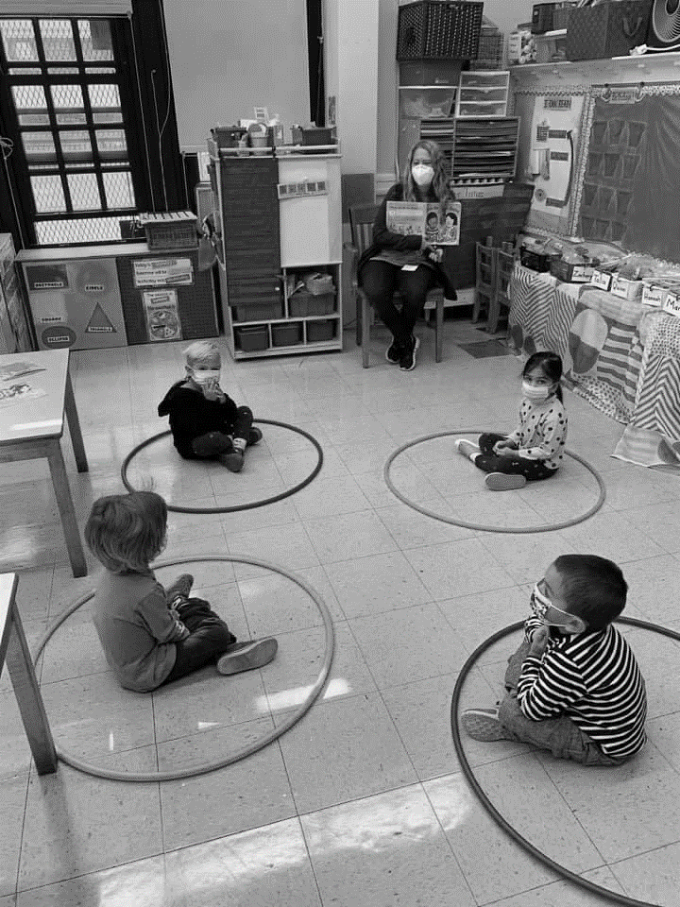
Figure 3. A prekindergarten class distancing during story time. Posted by their teacher.
Kindergarten children spent their school days behind plexiglass partitions that were affixed to their desks. Liz emailed me her thoughts, “We had a zoom parent teacher conference and the teacher gave a view of the room, it sent chills down my spine, the plexiglass around the desks looked like jail.”
In addition, each child was expected to bring to school every day their own supplies stored in Ziploc bags, and sometimes even a special toy or “desk pet.” At lunch time, the children ate their lunches at their desks. They were allowed to remove their masks, however, there was no talking as it was thought saliva would spread the virus. My daughter-in-law explained that, “Since Stassi was not able to interact during lunch, I pack her lunch box with lots of notes. I write her a letter every day, add a joke of the day, or some cool facts.”
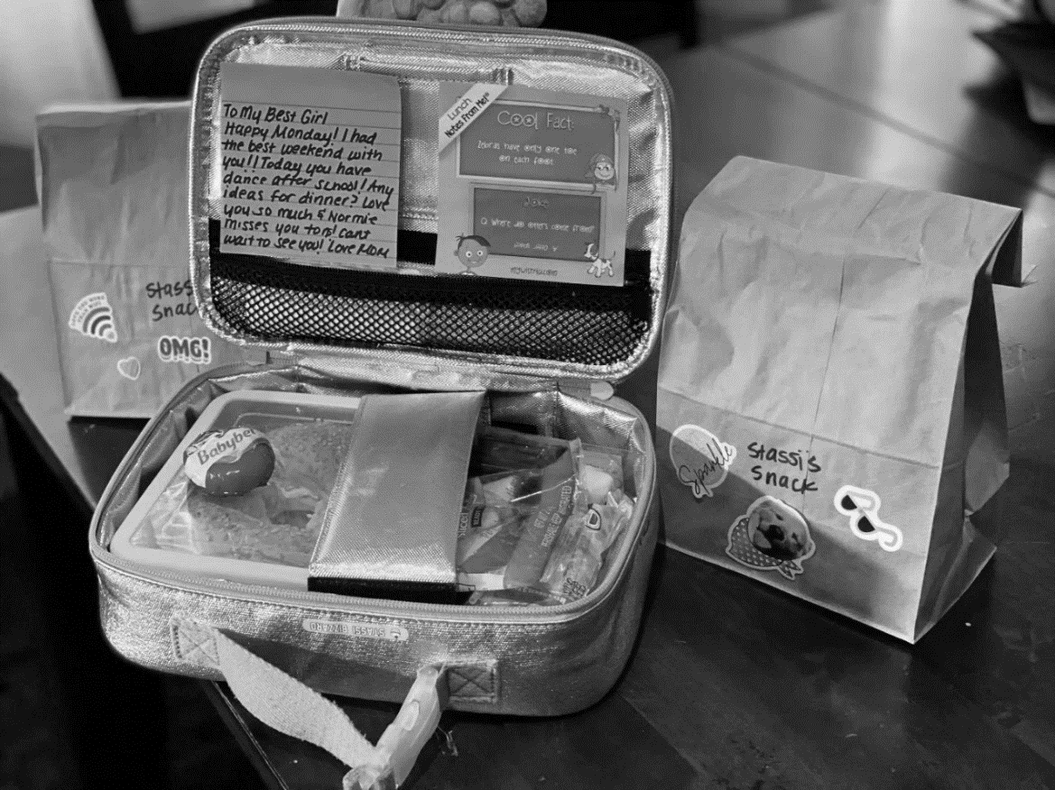
Figure 4. Stassi’s lunchbox. She was able to read the notes and messages her mother carefully placed inside, and often wrote notes back to her. Their daily communication through writing sustained Stassi’s spirits.
“In-classroom” recess was the norm in those beginning months, but when the weather became warmer children were designated socially distanced spots outside. They could draw with chalk on the schoolyard, or stretch and played on individual yoga mats. Holidays came and went, yet the partitions remained. Below, my granddaughter Lilly celebrates Halloween with her classmates.
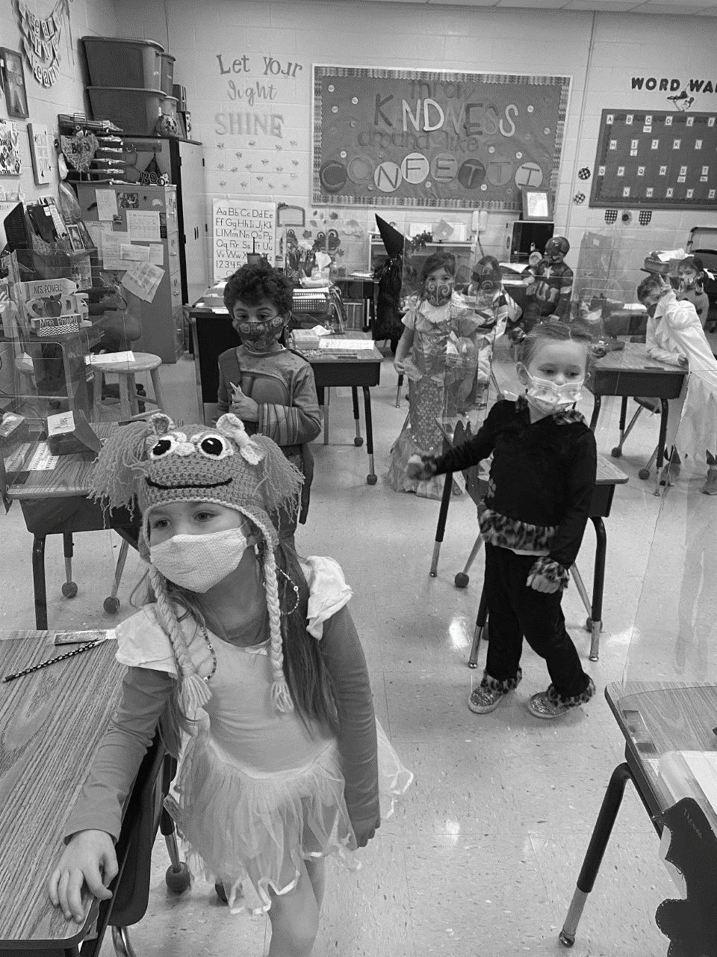
Figure 5. Lilly, my granddaughter, with her kindergarten classmates.
According to the American Psychological Association (2020) “Interpersonal relationships and communication are critical to both the teaching-learning process and the social emotional development of students… Emotional well-being influences educational performance, learning, and development” (p. 3). I was able to perceive how school friends and a caring and knowledgeable teacher helped Lilly to overcome much of her shyness, and motivated Nastassia to want go to school.
We were hopeful in the fall, but then Coronavirus began to surge again. This parent posting on the New York City parents’ forum, announced the implications, “My daughter’s school is preparing us for closure. We have to go today and pick up supplies from the school. She was sent home yesterday with a large packet dated till after Thanksgiving.”
Mask Mandates
The second largest theme in parents’ comments was related to wearing masks. Their postings were divided between feelings of understanding, acceptance, frustration, and calls to “take a stance.”
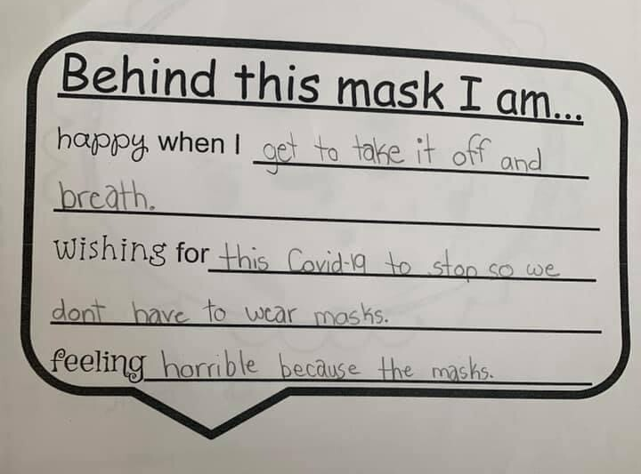
Figure 5. One parent posted this worksheet that her third grader brought home from school.

Some parent postings were light hearted, such as Dee’s joke “Can we move schools to restaurants, so students can take off their masks when they get to their tables?” Others shared what they learned about their child. For example, Ellen wrote in an email, “He did forget to put his mask on the other day … he asked if he was going to get Coronavirus...this has made me realize that 1. kids are very perceptive but 2. they are very resilient and adaptable.”
Kristen shared a positive story, “My 4-year-old has always been excited about the masks. My parents sent him his first one from Florida, and it was camo which he loves. He knew he had to wear it to go to Target and didn't mind b/c he loves Target.” In another email, Caryn wrote “He wears it to Pre-K for his 3-hour day and I’m not sure he even notices anymore. He has never really asked why about the masks. I think my anxiety about the masks for him at school was way worse than anything he feels or has expressed!” Similarly, Marjorie emailed, “Doing fine masks all day plexiglass 6ft distance, my second grader had some tough days I think, not being able to interact with his friends and stuff. I think it bothers me more than them.”
Kathleen, mother of a first grader who is on the autism spectrum, shared her son’s experiences:
My son is in first grade and doing fine with the mask, and he’s on the spectrum and has sensory issues. He says it’s his own spaceship and loves that no one can touch his supplies! They get to keep the water bottle on their desk at all times, loves lunch at his desk because he doesn’t have to be smack up against everyone else’s food, LOL. They definitely get to socialize!!...They can’t always play in the room with each other and build blocks, but they can socialize and talk with each other the whole time. They get plenty of mask breaks…and don’t need to keep it up outside. They even go outside a ton more now.
However, in her family forum posting Regina took a totally different stance:
Not acceptable! The CDC says sustained contact less than 6ft apart for more than 10-15 minutes. Take the masks off the children who are running around outside, under UV light in the open sky. There will undoubtedly be psychological consequences of them of falsely believing that they are in danger and/or a danger to others. Chronic stress and fear wreak havoc on mental and physical health…Take a stand people!
Students with Special Needs
Students with special needs had differing experiences with ever-changing school schedules, PPE, and learning platforms in the fall. Jessica, from a Long Island family forum wrote, “My child is on the autism continuum. The first time we used ZOOM he became very upset. He screamed, ‘I’m scared. I’m scared. I’m running away.’ Eventually I got him to peek into the screen.”
Denise shared her frustration about her son and daughter, and the ways their needs were not being met. She writes about her attempts to meet with school official before the school year even began:
My younger son has an IEP and is struggling. I tried meeting with staff earlier this year, and again before the school year. But it is rough, disorganized, and creating some serious harm at this point. We chose remote but had the option of in-person. But in-person brings its own challenges for special needs students too, as the restrictions would be problematic. We can’t win no matter what we do and his education, and all of our sanity, is suffering for it… My first-grade daughter will very adamantly tell people she HATES school…They promoted her from K to 1st when they shouldn’t have, and they did it because of Covid. They figured they would push everyone through. Hold no one back and figure it out in the fall. But, now she’s just behind with NO plan to “figure it out.” As if being virtual were not hard enough, imagine doing it at a grade level you are not ready for.”
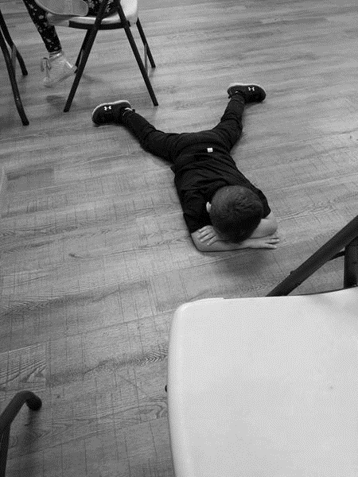
Figure 6. One parent posted this photo of her child’s “meltdown” during the first day of remote learning.
Elaine shared that when her son (diagnosed with ADHD) returned to school for in-person learning, he had become increasingly phobic about germs. “He won’t touch the toilet handle, or doorknobs.” Getting through the school day is challenging for him.”
This post written by New York City mom, Georgina. She expressed strong feelings about the ways her child with special needs was being shortchanged:
I am so ANGRY with how NYC is handling our schools. My son JUST started in person again November 2nd where he receives SPEECH, OT and PT bc he is on the spectrum. REMOTE LEARNING does NOT WORK for him!!!! We can’t catch a BREAK! So now he has to transition from being home to school, and then if another lockdown transition back to home to them have to transition BACK TO SCHOOL?

Mandatory COVID Testing
When a “robust, mandatory COVID testing program” for school children in Grades 1 – 12 was initiated by the New York City Department of Education, parents protested across the city for weeks. Forum postings reflected their frustration and anger. Miriam wrote, “I’m feeling nauseous about the letter for random COVID testing we received.” Jessica responded, “I’m furious. It states that they ‘encourage’ us to give consent, but the bottom of the form says if I refuse to sign, my child may be required to go fully remote… How is this legal???”
Vivian extended the post by stating, “I have been in work every day and have not been required to be randomly tested. But now my poor kid will if I consent. If I don’t...she can be made to stay home.” Antoinette pointed out the social and emotional repercussions “How will my child be emotionally affected by this random testing? Waiting for results? Feeling anxious?”
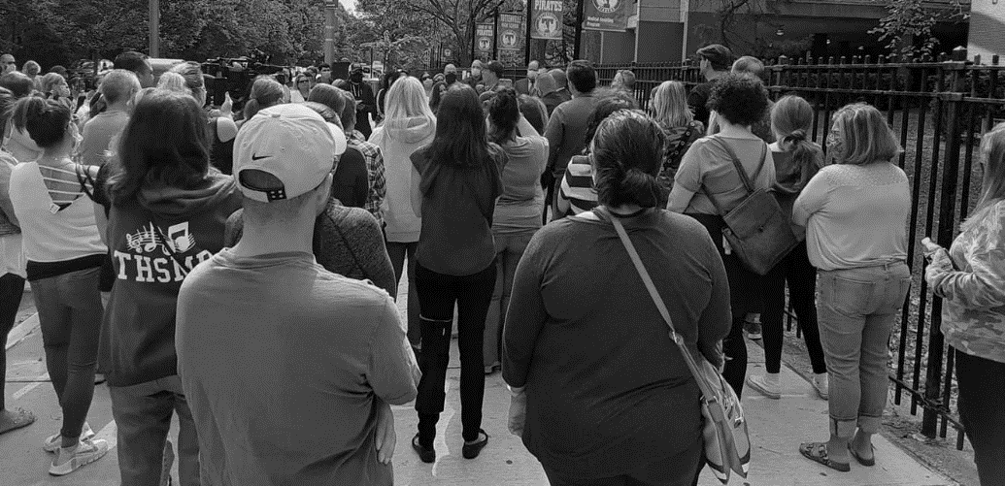
Figure 7. Parents meet to protest mandatory testing or remote learning options in New York City.
Some Sense of Normalcy

New York City students returned to school on December 7th. Except for parochial school students, most children attended virtually for a couple of days each week. Halloween and Thanksgiving had passed, for the most part uncelebrated, so children looked forward to the Passover and Christmas holidays.
Their letters to Santa reveal how the pandemic had influenced their thinking, and changed their childhoods. They also show their empathy, magical thinking, and concern for others. Emma wrote to Santa, “Are you okay, how are you immune to Covid?” Spenser asked for a favor, “I don’t want anything for Christmas, but I would like to ask you if you can do me a favor: can you please find a cure for Covid-19 and give to us to save the world. Thank you!
It wasn’t until nearly a year later (March, 2021), that middle school and high school students returned to in-person classes. Shortly afterwards, parents/students were informed that standardized testing in the English Language Arts (Grades 3-8) would begin in May. Parents, who were already concerned about “learning loss,” began to plan new protests.
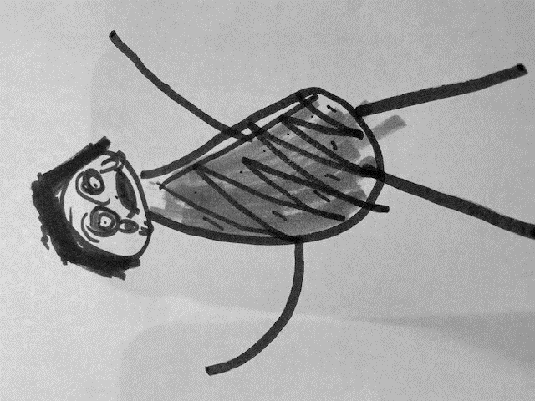
Figure 8. This picture, drawn by a kindergartener in a parochial school in February, depicts “God crying because of Coronavirus.”

Conclusion
The purpose of this chapter was to re-present the collective voices of families and their young children, and to describe their experiences during the year-long COVID- 19 pandemic. Themes related to the effects of virtual or hybrid learning, social distancing, and the use of personal protective equipment (PPE) during the pandemic emerged from children’s and parents’ comments. The critical impact of virtual instruction upon students with special needs opportunities, was a theme that came to the forefront.
Remote/Hybrid learning
During the “Covid Crisis,” school districts in New York attempted to implement an instructional approach that was completely new to teachers, administrators, students, and parents. Subsequently, broad inequities such as access to technology, individualization of the curriculum, modifications for children with special needs, and consideration for children and families living in poverty became apparent. Schools realized that providing children with devices to access instruction was not enough, especially for those without internet access. More professional development for administrators/teachers, concerning the applications and implementation of virtual learning platforms is paramount. School districts need to tweak their budgets to move beyond purchasing Chromebooks to investing in personal computers (PCs) for student use. Most importantly, they must explore ways to provide Wi-Fi to students who do not have access.
We have yet to determine the long-term effects of remote instruction upon young children’s learning and achievement. However, we can begin to envision ways to make remote learning more engaging, meaningful, and accessible for the Next Normal. Perhaps, we can develop a model for instruction that is generated and built upon students’ evolving theories and questions? Such a plan, would have been beneficial for young children whose childhood was so changed, had many questions about Covid-19, and who had missed so many valuable classroom experiences.
Those parents who chose to homeschool their children were pleased with their progress. In fact, I reconnected with Ally who decided to homeschool her son in the spring of 2020. She and her husband are still doing so, and believe the “one-on-one” instruction is the best method for their child. He adapted well to the schooling change, but Ally is seeking out additional opportunities for social interaction with other children of his age.
Concurrently, educators must carve out spaces for parents to engage and share their thoughts. Many participants felt they were overlooked and ignored from March 2020 to March 2021. We must do a better job of building relationship between home and school, that allow for productive and sustained conversations.

Social Distancing
Young children appreciated the time alone with parents and siblings. Parents also felt fortunate to have uninterrupted time just with their family. This special bond helped young children to feel nurtured and protected. Children did express, however, that they missed going to school even though they worried about the well-being of their friends and family during the quarantine and shut down months. They longed for the feeling of community. They craved the social interaction, for schools are much more than brick and mortar structures, they are children’s second homes. Young children’s words demonstrated that they valued their school relationships. Like all of us, they are social beings who need personal contact to thrive.
Mask Mandates
Parents’ comments in this chapter corresponded to findings of a recent report, (GreenMedInfo Research Group, 2021). In the GreenMedInfo report, 47% of parents reported that their children were more irritated, and 27% had developed more fears as a result of wearing mask and nose coverings (p. 4). In this analysis the average was about the same. Parents either totally disliked or had just become accustomed to blindly following the mask mandate.
I am pleased to say that Lilly’s “clinginess” is decreasing, but she is still apprehensive of strangers, and hesitant to interact with them. I can now perceive how her behaviors are related to her life experiences over this past year. One fifth of her life was spent in quarantine and lock down. The pandemic took a social and emotional toll on her and her parents.
Instruction of Students with Special Needs
Our most vulnerable population, students with special needs, received the least equitable treatment. Each story or comment from a mother of a child with disabilities, showcased their unique dilemma. Virtual/remote learning was not a good fit for extended instruction of students with special needs. Extended screen time proved to be deleterious, as social interaction was minimized. I keep thinking about Kathleen’s description of her first grader with autism who liked the plexiglass all around his desk. He thought it was his “own little spaceship” and “nobody could touch his things.” Although I admire her son’s creative thinking, I know his preference for social isolation is the last thing his teachers or parents want for him. Interpersonal relationships and conversation are critical to the teaching-learning process and the social-emotional development of all children.
I fear the neglect of young children with special needs during the pandemic will have long term effects. These effects will impact not only their future achievement and opportunities, but also teachers’ perspectives about responsibilities to meet the needs of all students requiring the “least restrictive environment.”
We must also consider the impact of reduced educational opportunities for children whose heritage language is not English. Though not described in this analysis, they deserve research studies that describe the short and long-term effects upon their social, emotional, and overall well-being.

References
Almy, M., & Genishi, C. (1979). Ways of studying children: An observation manual for
early childhood. Teachers College Press.
American Psychological Association (2020, May 18). COVID-19 virtual learning and education:
Social and emotional learning. Cord 19, Retrieved September, 23, 2020 from https://www.apa.org/topics/covid-19/education-social-emotional.
GreenMedInfo Research Group. (2021). Mask harms in kids: 68% of parents report
alarming psychological and physical problems in first-of-its-kind study. Retrieved Jan. 4, 2021
from https://www.greenmedinfo.com/blog/mask-harms-kids-68-parents-report-alarming-problems-first-its-kind-study-preprint1
Jalongo, M. R. & Saracho, O. N. (2016). Writing for publication. Springer Texts for
Education. Retrieved November 28, 2020 from http://doi-org-443.webvpn.fjmu.edu.cn/10.1007/978-3-319-31650-5_8.
Nassau Community Moms (n.d.) Home. www.facebook.com/groups/413400592045769/
New York Parents & Teachers Against Distance Learning (n.d.)
Home. https://www.facebook.com/lirinps/www.facebook.com/groups/3819987698075983/
NYC DOE Parents Coalition (n.d.) Home. https://www.facebook.com/groups/1232831240428278/
Smith, F. (1994). Understanding reading. Lawrence Erlbaum.
Suffolk Community Mom’s - www.facebook.com/groups/1501897846747338/
Vygotsky, L. S. (1978). Mind in society: The development of higher psychological
processes. Harvard University Press.
Wells, C. G. (2009). The meaning makers: Learning to talk and talking
to learn. Multilingual Matters.

